

SRI LANKA INSTITUTE OF INFORMATION TECHNOLOGY

[**Enterprise Standards and Best Practices for IT Infrastructure**](http://courseweb.sliit.lk/course/view.php?id=137)

**4th Year 2nd Semester 2014**

Name: Chandranath R. D. S. P

SLIIT ID: IT 13 0629 34

Group Number: June Intake - 2013

Practical Session: WE Monday

Practical Number: Lab 4 (Bare Metal)

Date of Submission: 16/08/2016

Date of Evaluation : _____________________

Evaluators Signature : _____________________

**Bare metal Virtualization**

As you may know, VMware recently released ESXi 5 (Hypervisor) and, with it, a plethora of new capabilities. In order to familiarize yourself with ESXi 5, you’ll need a platform from which to test.

Before you get started, make sure you understand that the free version of vSphere Hypervisor (the official name for the free ESXi 5) has some limitations:

* Has a limited vRAM entitlement of 32 GB for the server. This is probably the biggest limiting factor.
* Cannot be managed with vCenter due to the free product’s lack of a vCenter Server Agent. You must use the vSphere Client, which we’ll be installing as a part of this article.

To get started with your installation of ESXi 5, insert the ESXi 5 disc into your server and start it up. In my installation, I’m installing ESXi 5 under Fusion. Obviously, this is for demonstration purposes only.

**Step 1:**

Using VM Ware workstation create a new virtual machine using ESXi 5 VMvisor installer.

After creating new virtual machine you will get a window to select your installer select the first one saying “ESXi-5.0 standard installer”

Then your ESXi installer will load its files into the virtual machine in order to get installed.

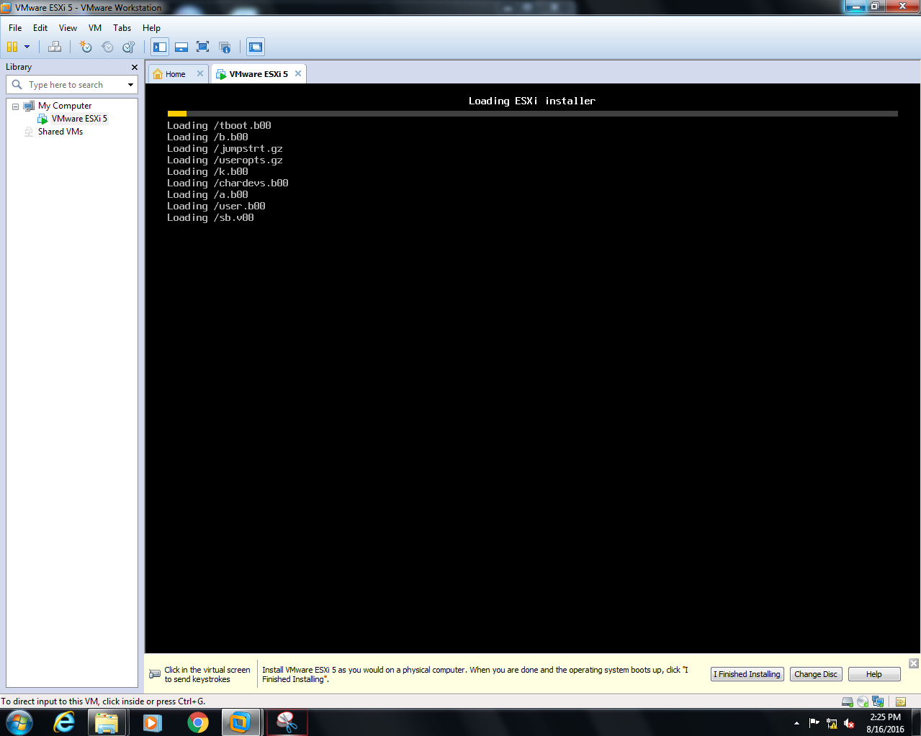

Then you will get another boot screen

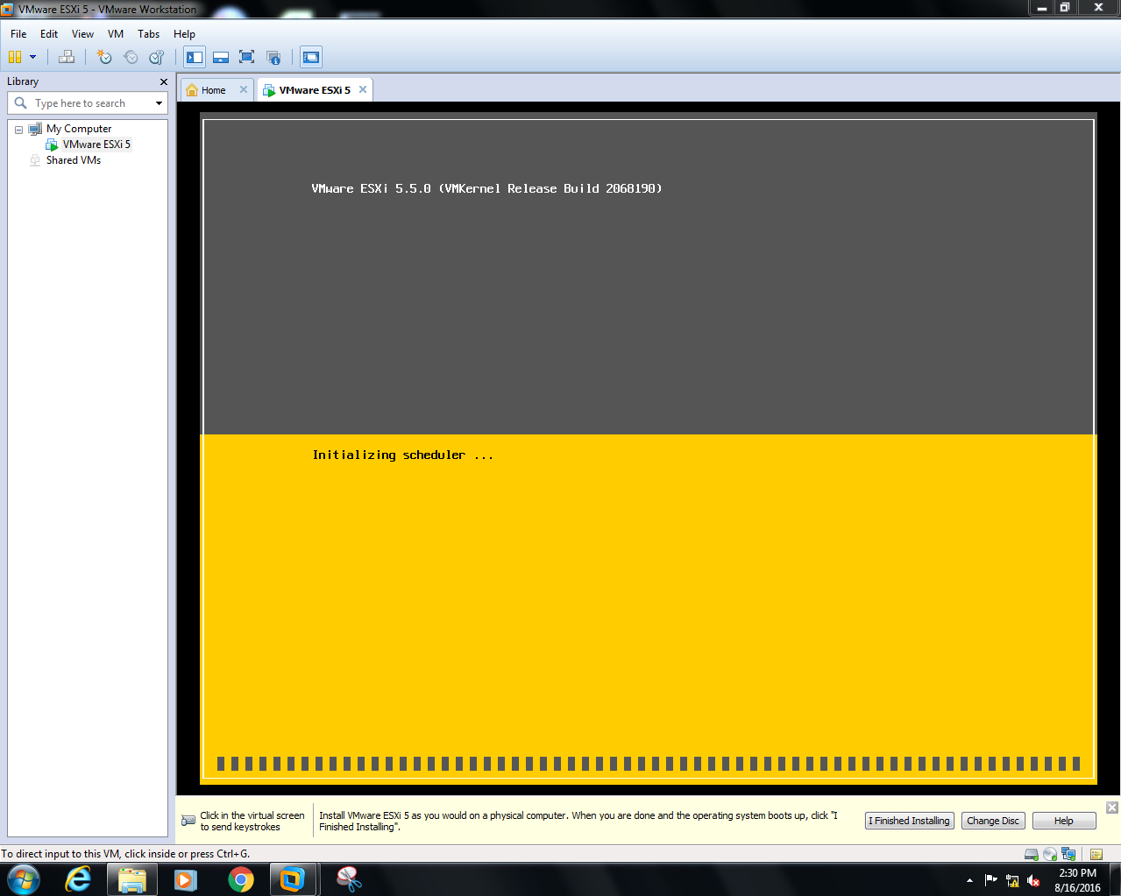

With the preliminaries out of the way, the ESXi 5 installer truly kicks off with a welcome screen containing information regarding VMware’s Compatibility Guide. To continue with the installation process, press Enter.

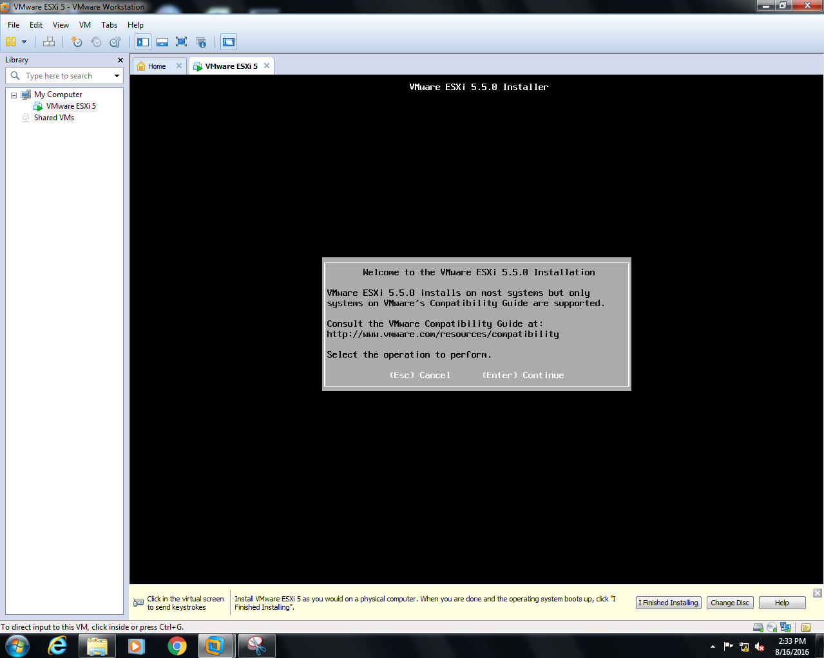

Of course, no installation would be complete without having to accept an end user license agreement. To accept the agreement as a part of the installer, press F11. If you don’t accept the agreement, press Escape to abort the installation. You can see this screen below.

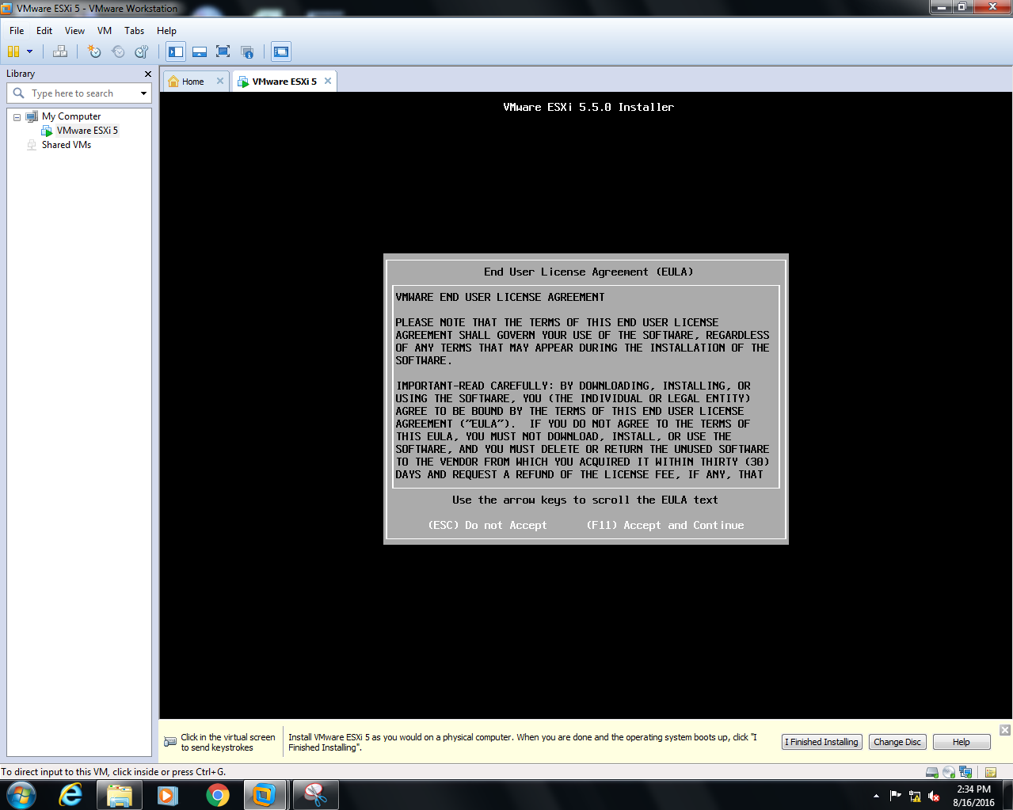

A location to which to install ESXi 5 is the first technical decision you have to make. Below, you can see that I have a single 40 GB volume from which to choose as an install location on my machine.

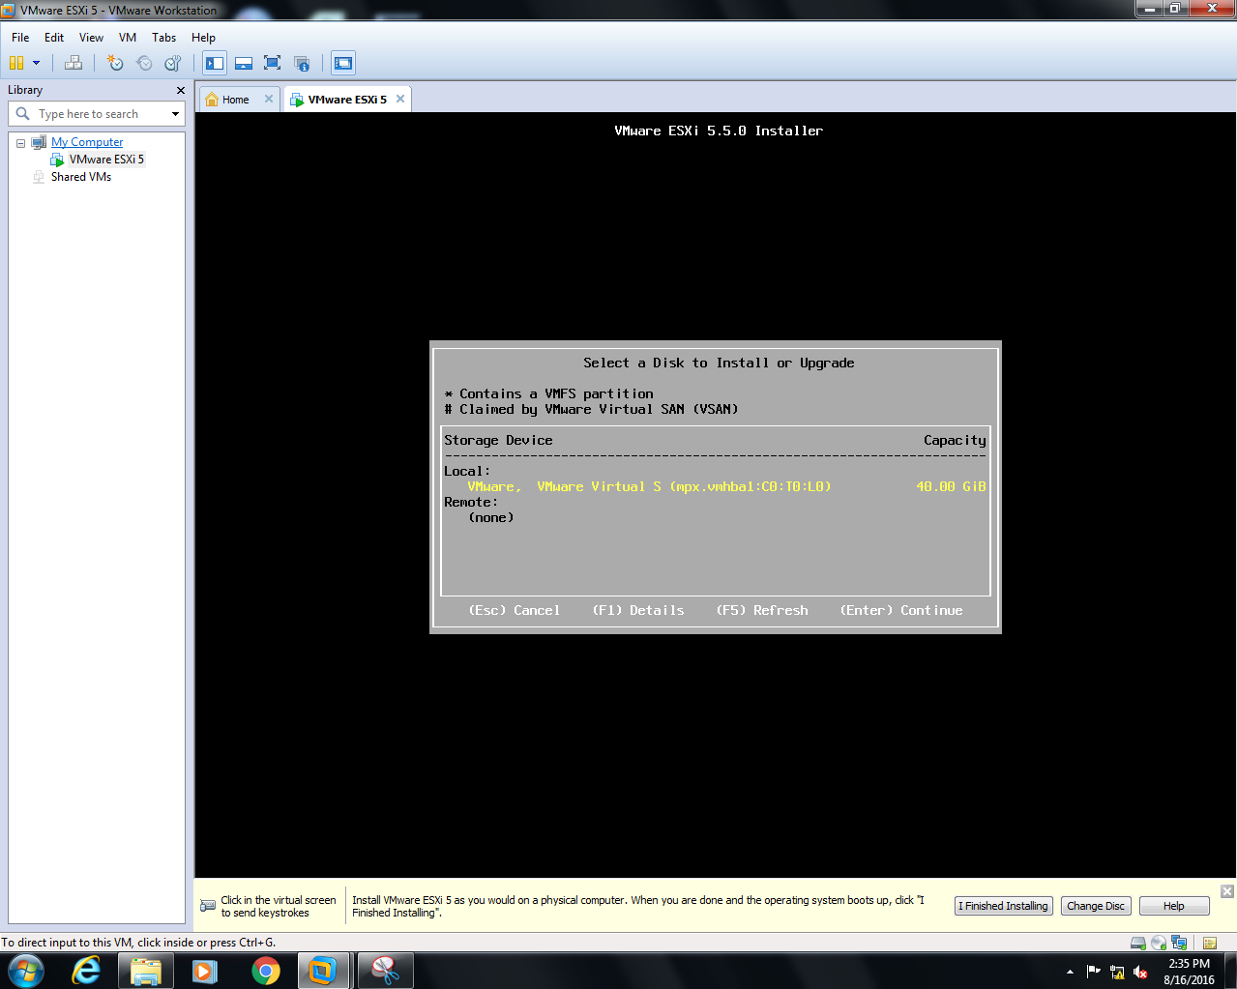

Next step, as shown below, choose your keyboard layout, I’ve chosen the US Default option.

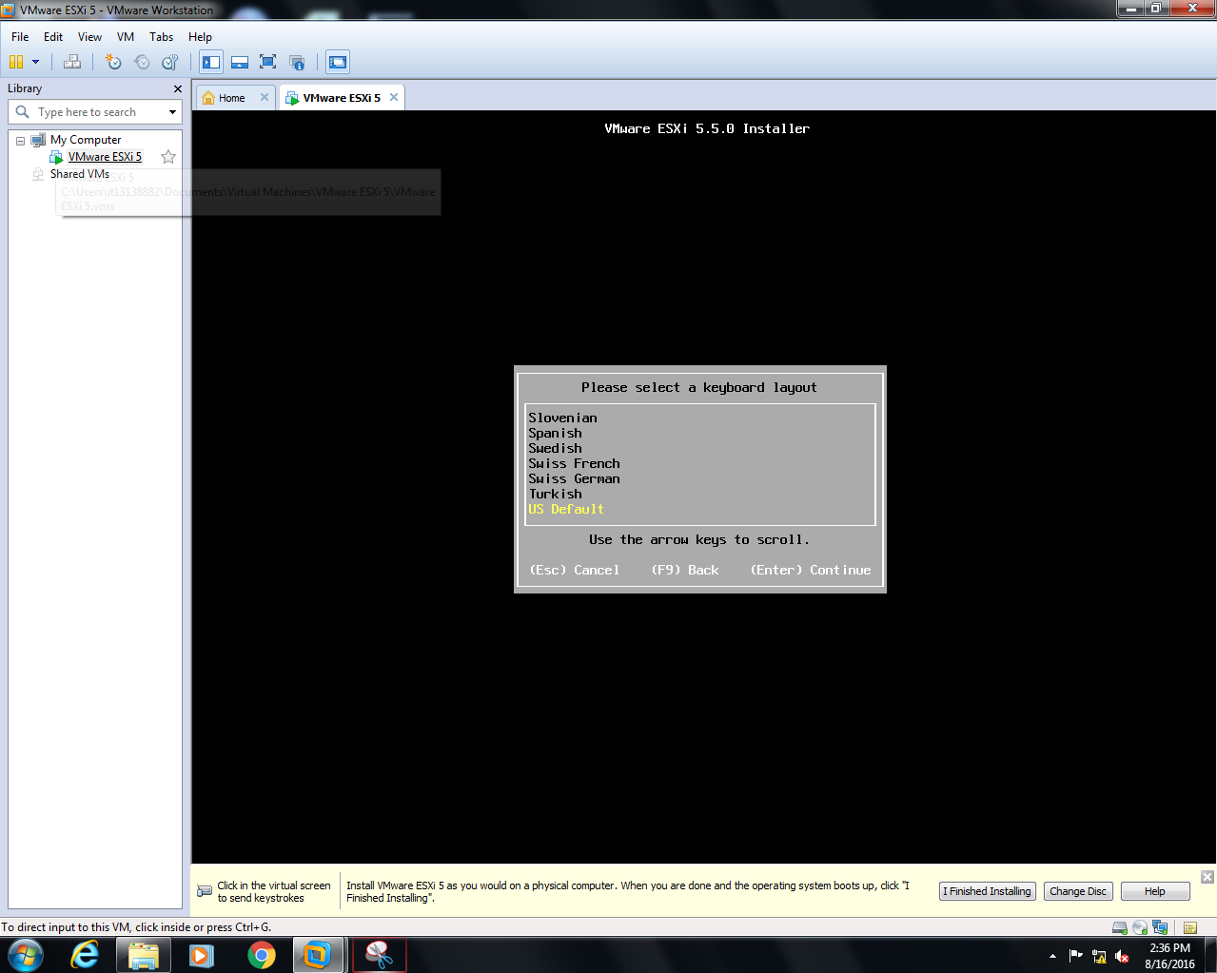

The root password on your ESXi 5 system is the key to your virtual kingdom, so choose with care. Make sure you provide a strong password. As you can below, you have to provide the password twice to make sure you don’t include any typos.

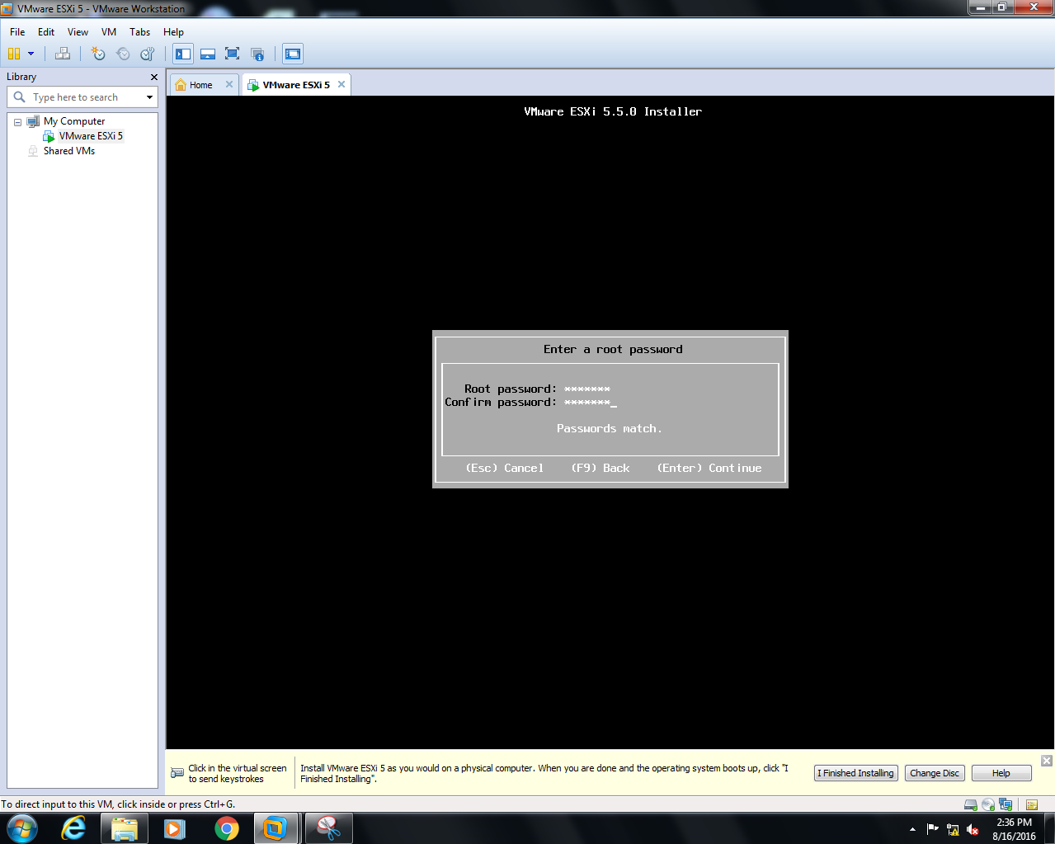

The ESXi installer now scans your system to get additional information, once that’s complete, you’re asked to confirm the installation by pressing the F11 button, once you initiate the installation, your selected disk will be repartitioned. Throughout the process, the installer provides you with an installation status like the one shown below.

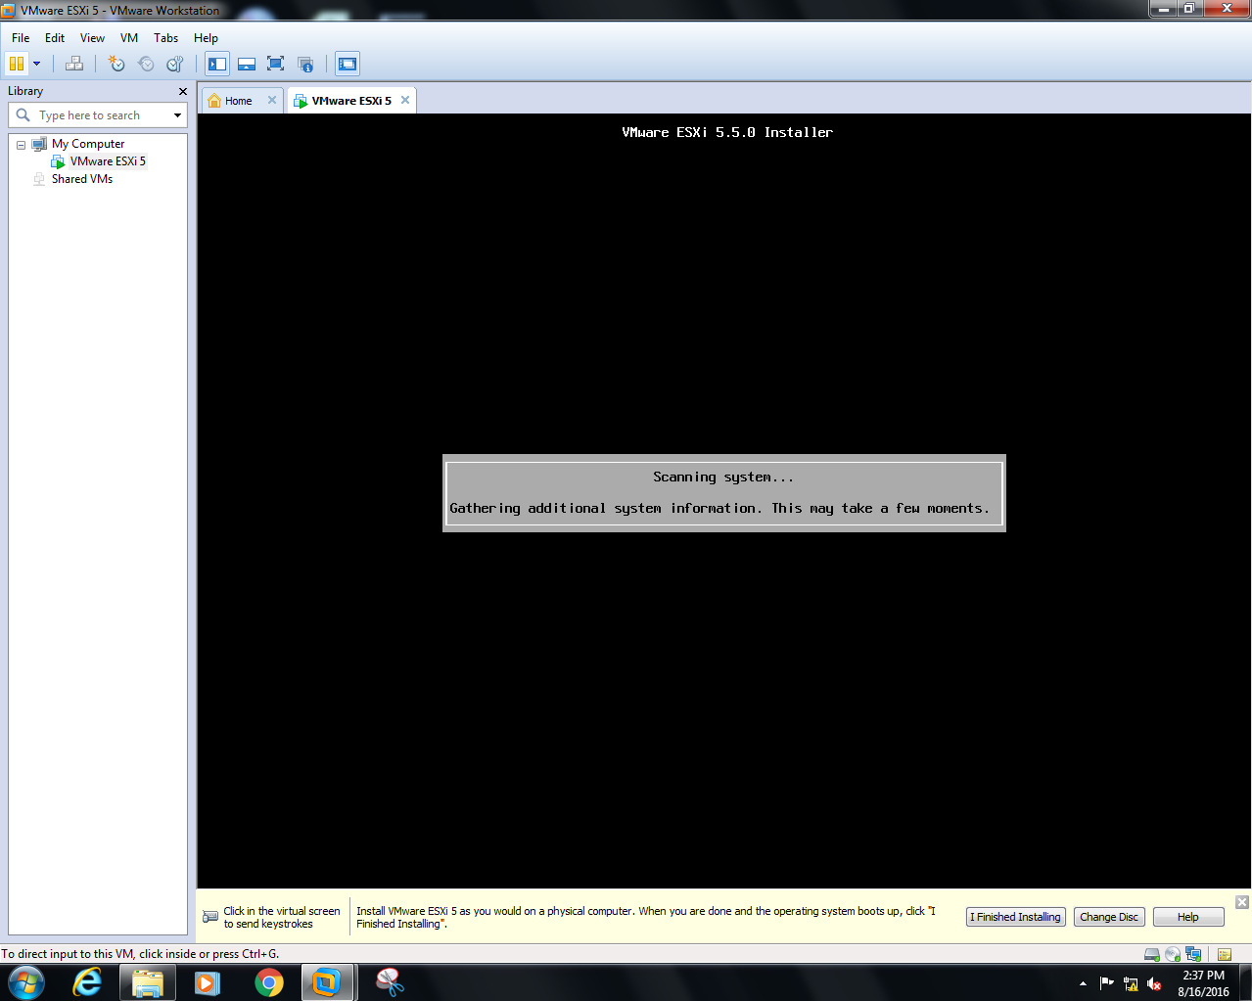

Then confirm your installation by pressing Enter, I ignored the warnings in my case,

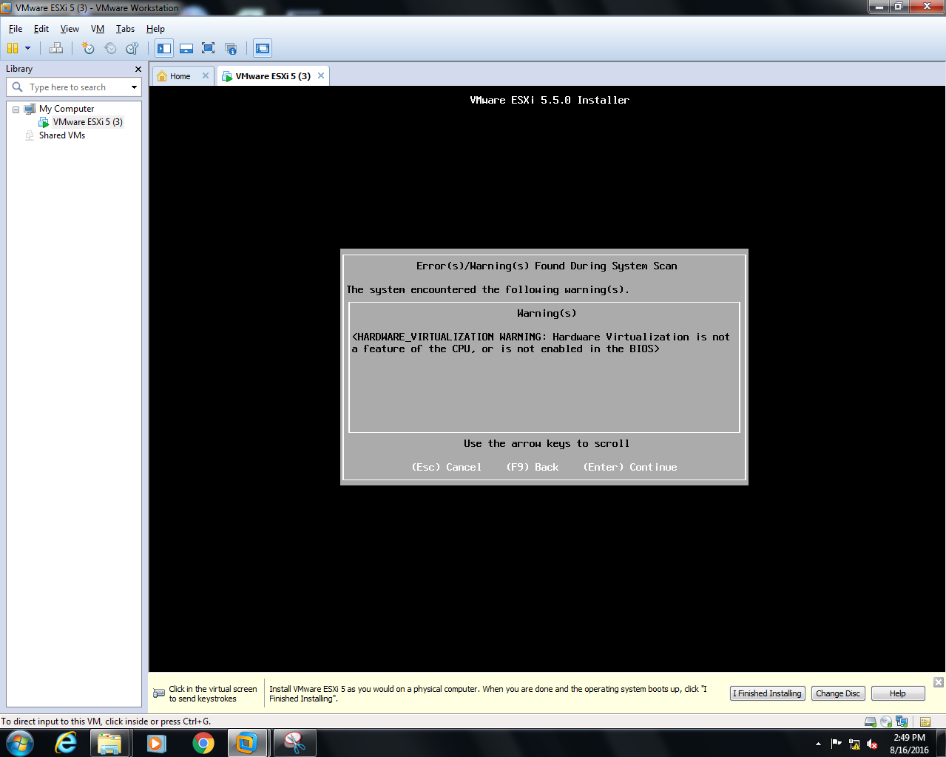

Now your bare metal hypervisor is installing on top up of your virtual machine see the figure below.

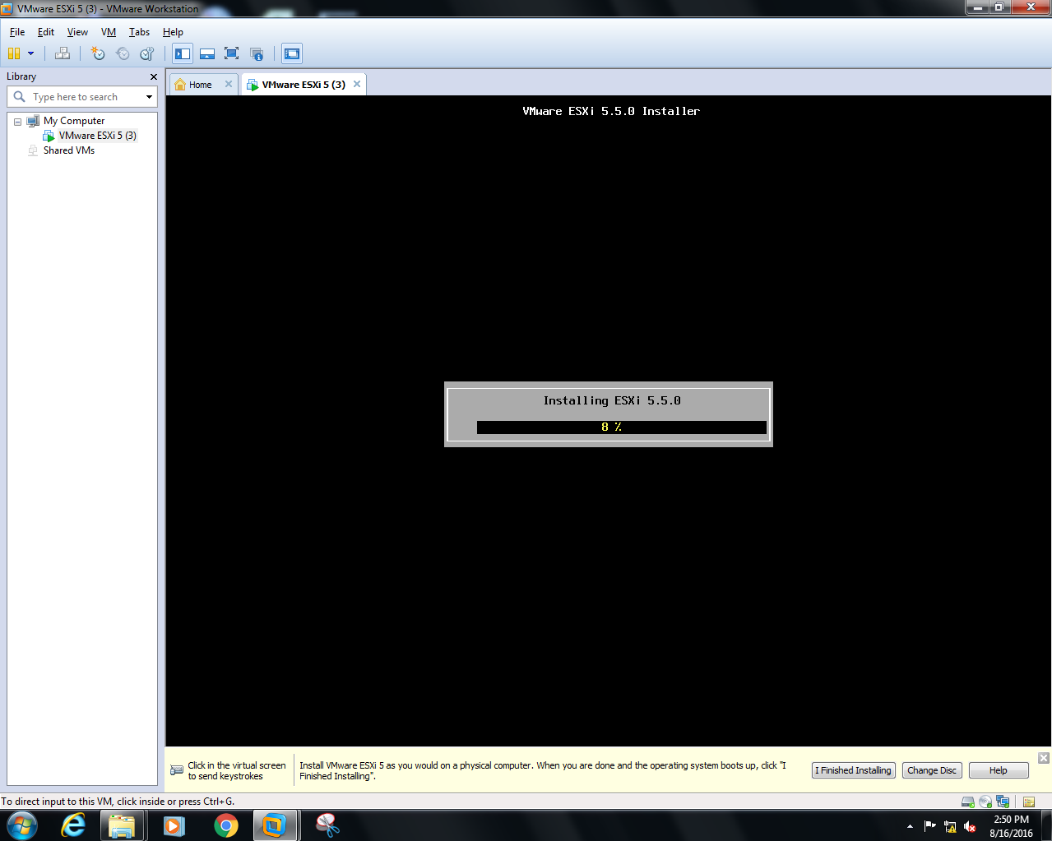

When the installation process has finished, you’ll get a message indicating such installation complete, in order to get your server details you need to reboot your virtual machine.

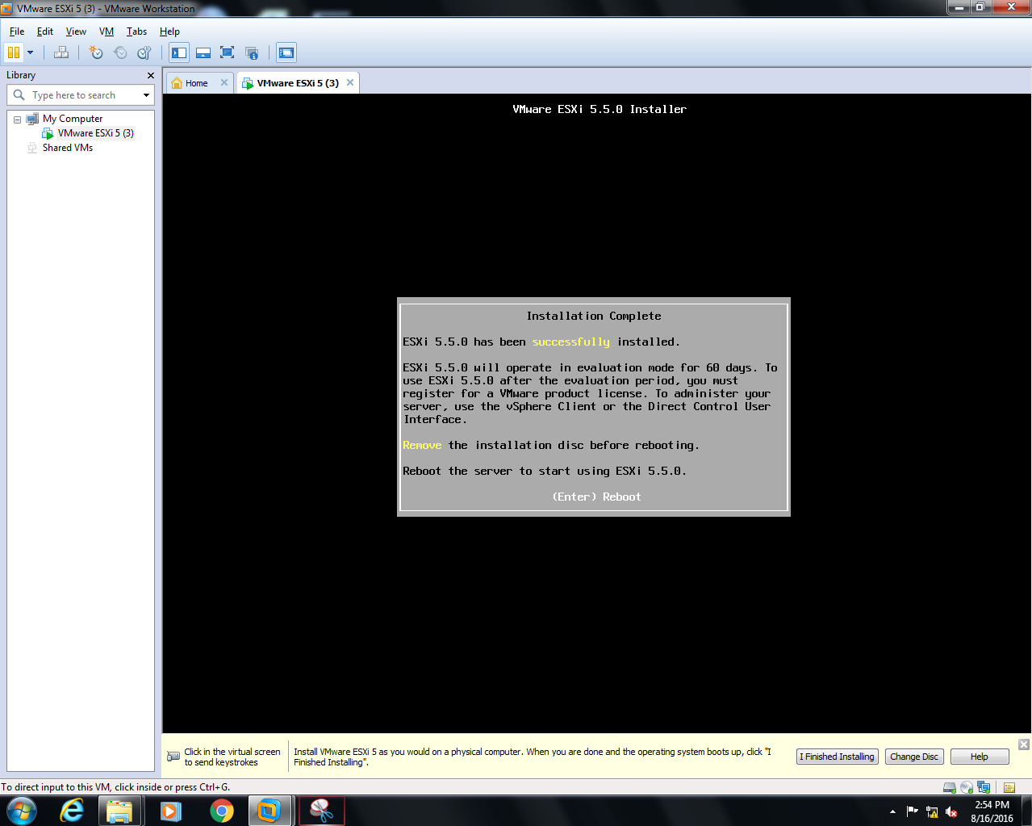

The last screen you’ll see is a yellow and gray one like the one shown below. Take note of the IP address on the screen.

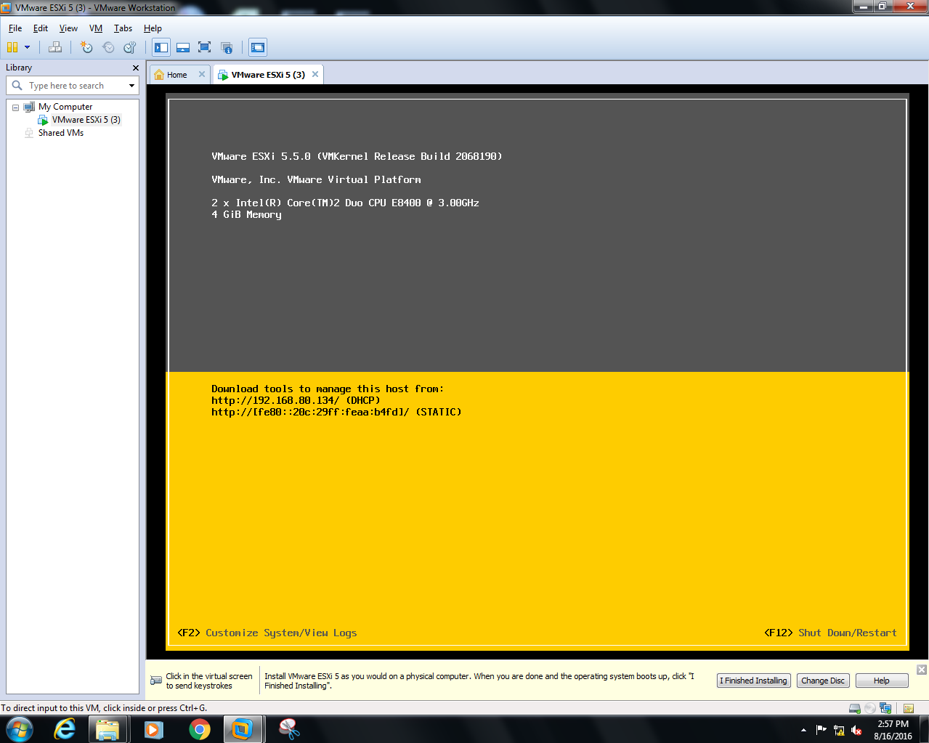

**Step 2:**

In the previous part of this series, we laid the groundwork for your new ESXi 5-based virtual environment by going through an ESXi 5/VMware Hypervisor installation. In this part, we’ll create a virtual machine using vShpere Client Application.

You can log into that server using your browser but the connection is not trusted, anyway you can use unsafe mode and go the site

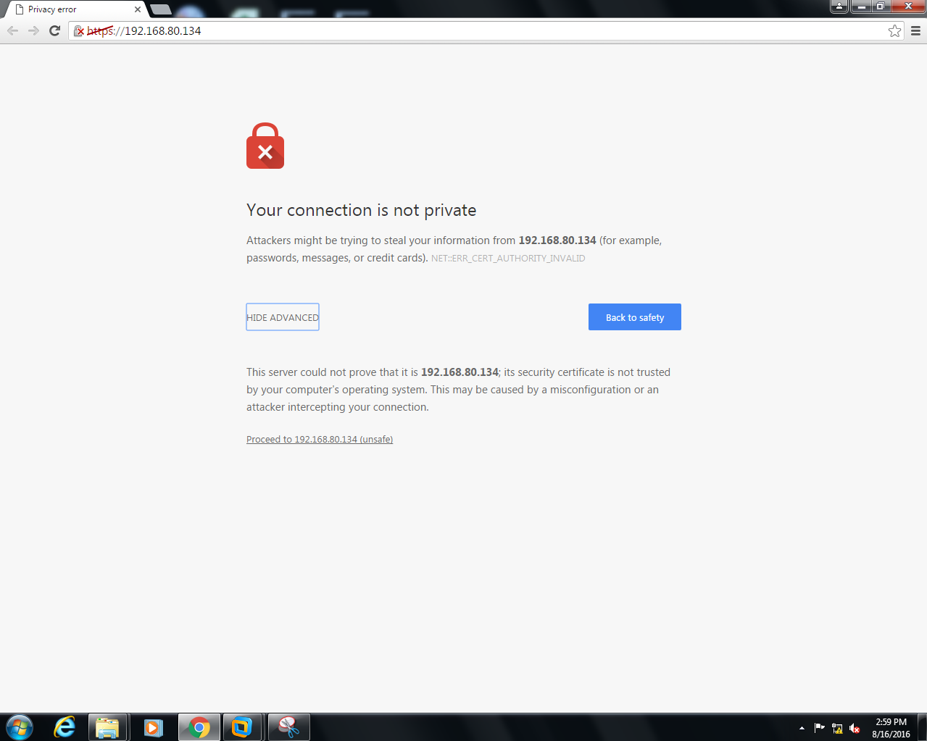

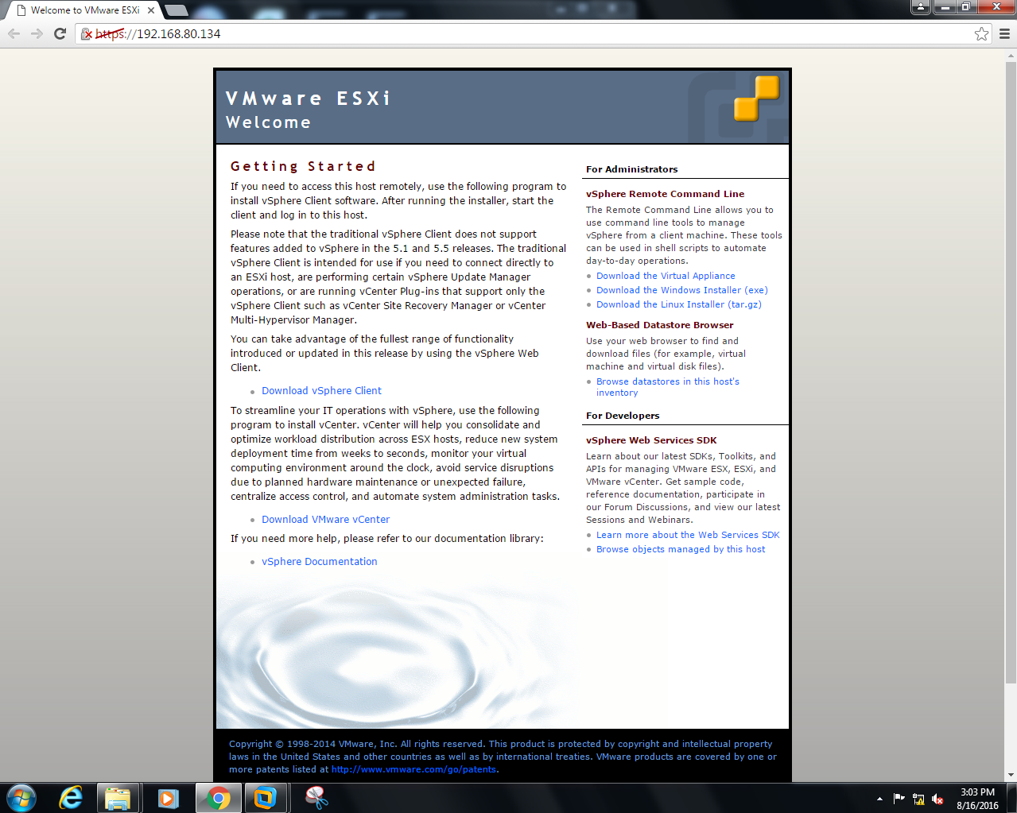

After successfully downloading your vShpere Client software you can create your virtual machines. To connect with your server you need to fill your ip address, username and password.

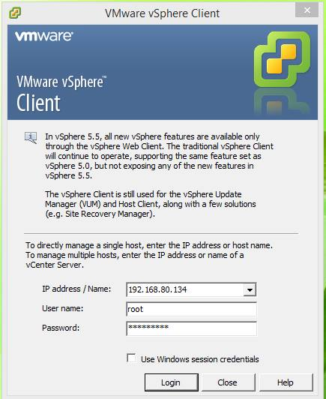

Once you’ve gained access to the vSphere Client, right click your server IP address and choose New Virtual Machine.

The first question is a simple one: Do you want to use Custom settings for your new virtual machine or do you want to use settings that typically work well based on the operating system you use? For the purposes of this demonstration, I’m choosing the Custom option.

Now, provide a unique name for your new virtual machine. Before providing name you have to go through some steps, but leave them as default. After creating the virtual machine, go to the inventory tab and go to storage sub category,

Then choose a data store

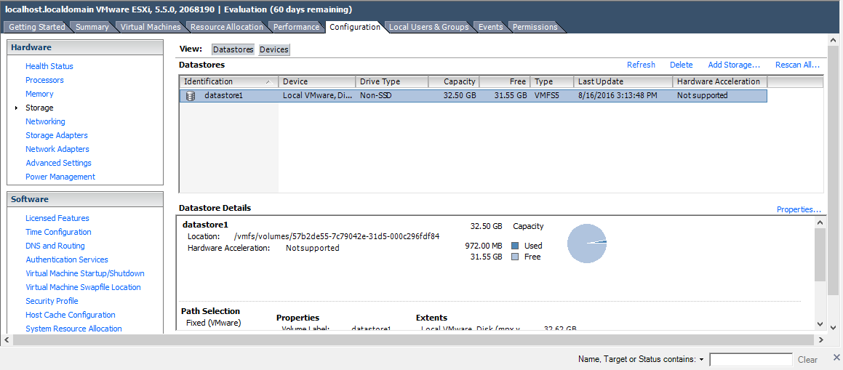

Then you have to browse your data store in order to store data,

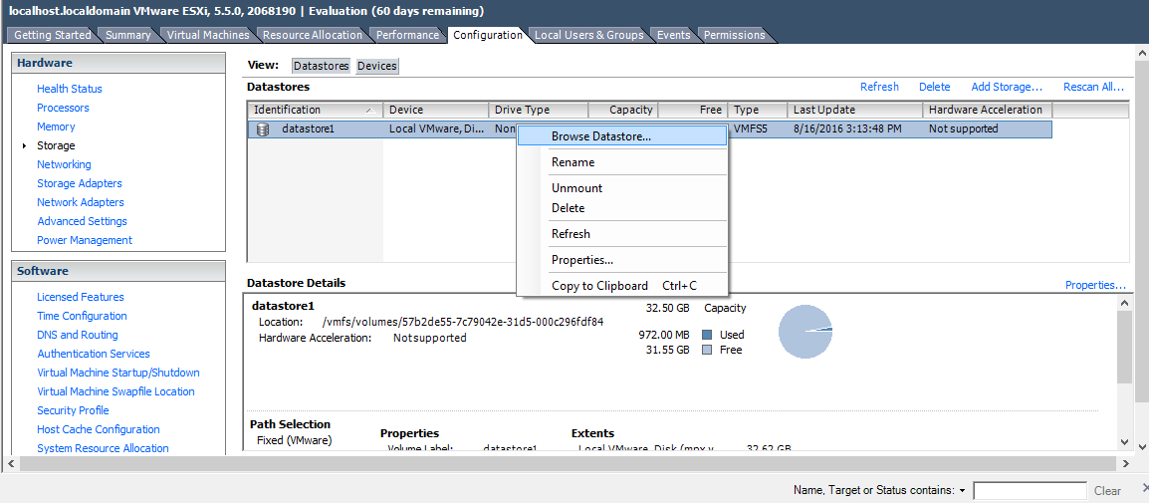

Browse data from your host computer to this server

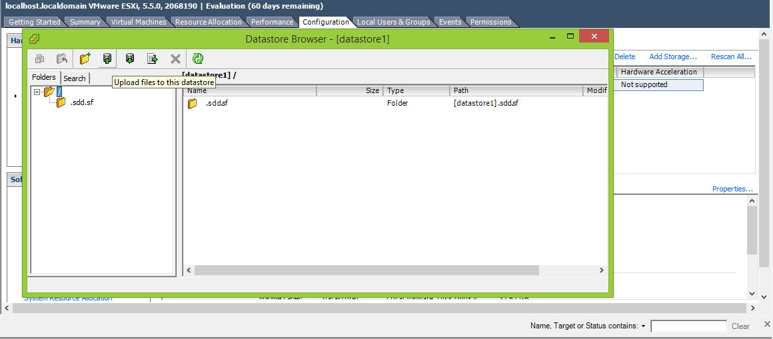

Since our lab was based on Kali Linux here I use Kali linux os image file

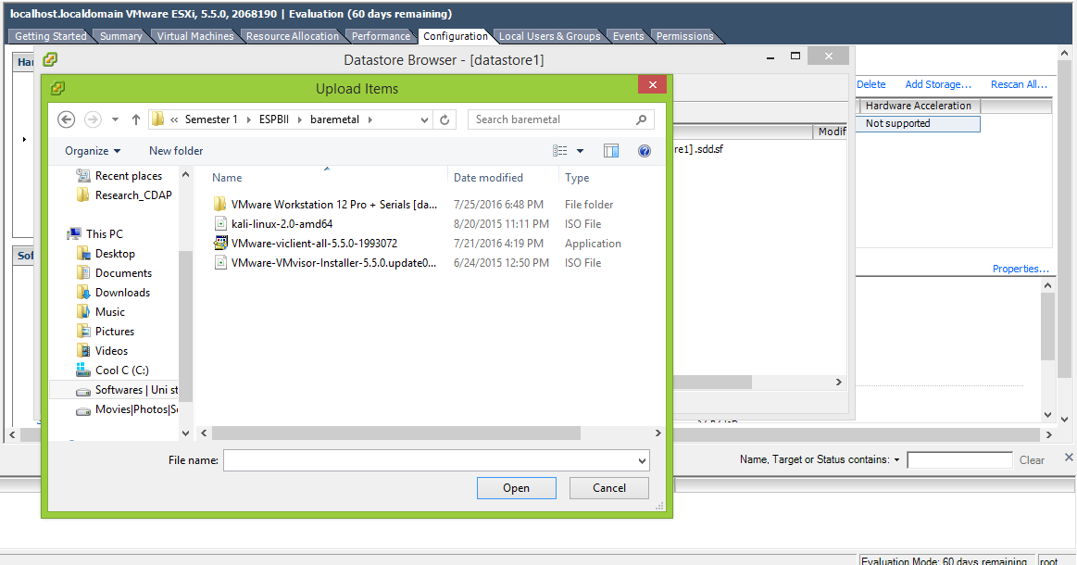

After selecting it it will be uploaded to the server datastore

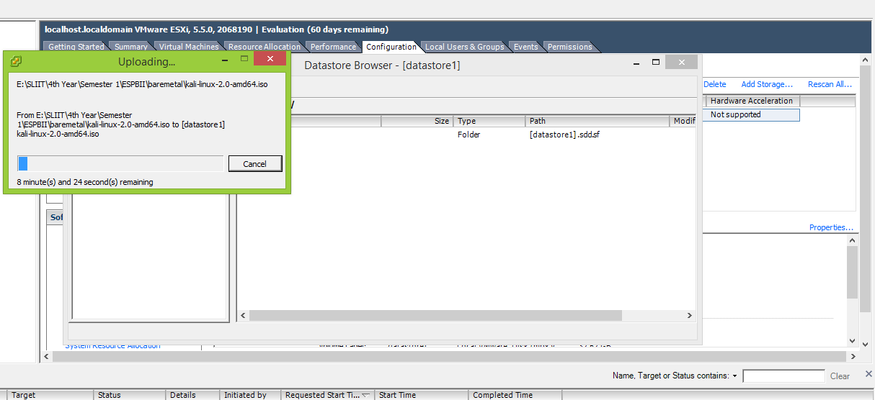

Now your Kali linux os file is in the Datastore

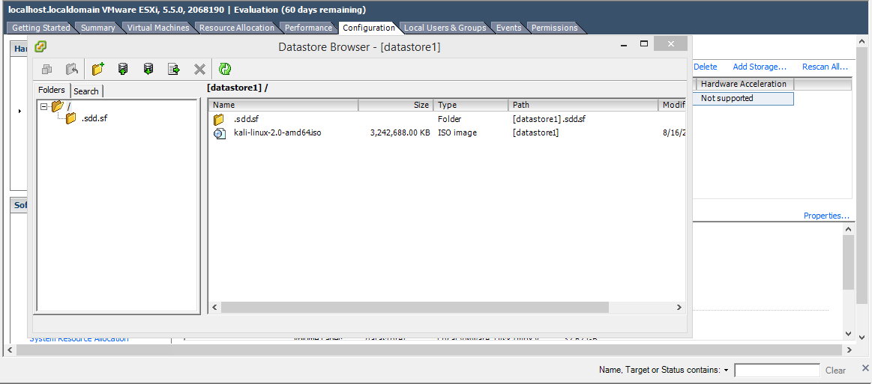

Using that iso file now you can create new virtual machine, since we are using kali linux select Debian/GNU as your option

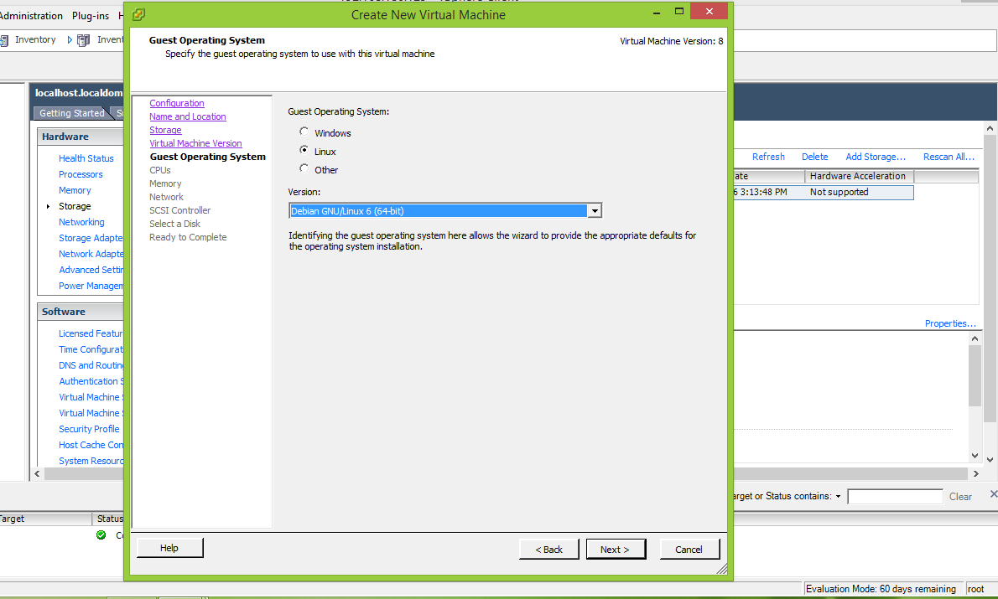

After creating your virtual machine make sure your virtual machine settings are same as below

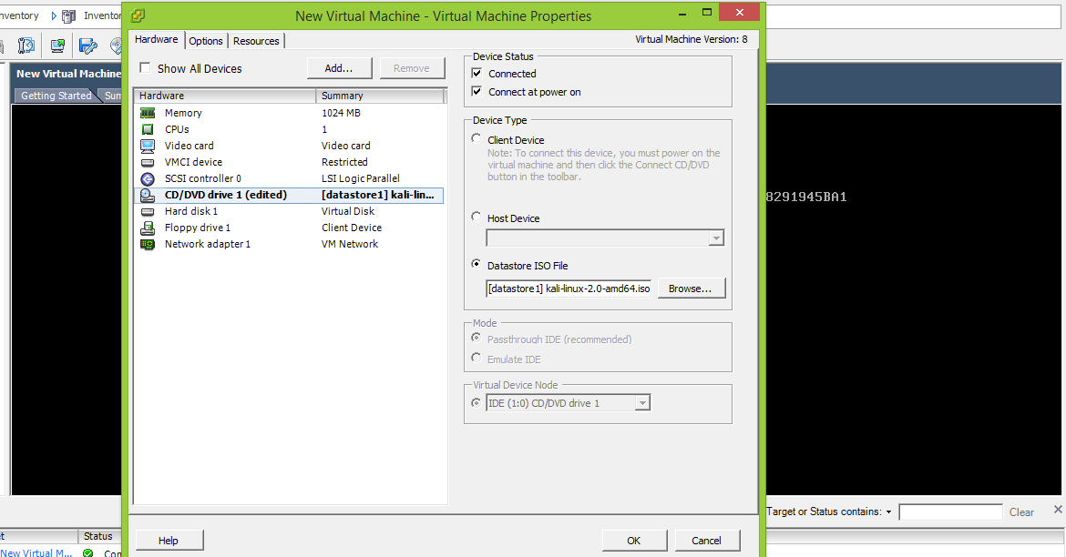

Then power it on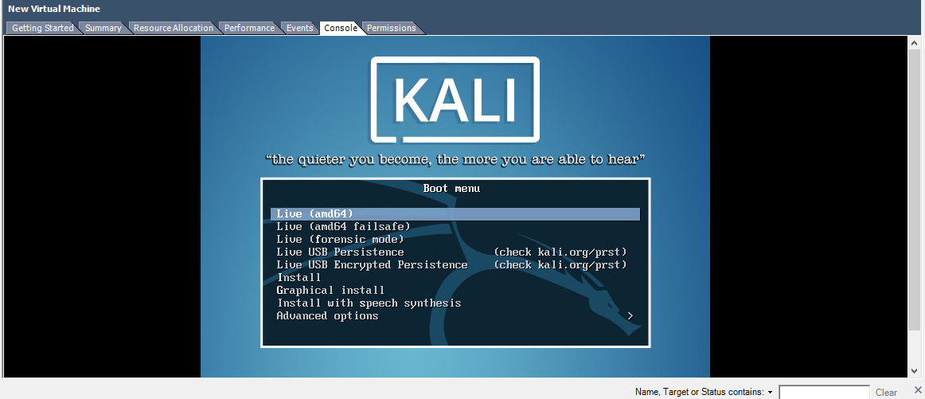

Finally you will get your Kali linux console. ☺